***Human Rights:***  ***Where does slavery begin?***

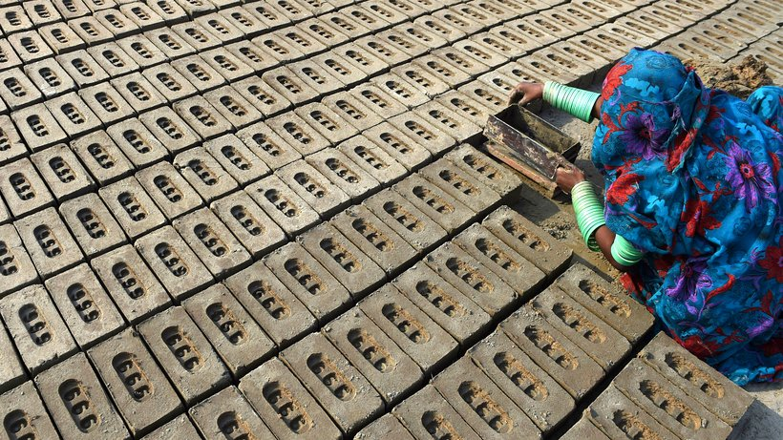

**Introduction:**

This report aims to present facts about and reasons behind modern slavery. It also shows the drivers behind the business of bondage.

**Facts & figures:**

Unfortunately, slavery is still a big business today. In the year 2016, 40.6 million slaves were counted - 25 million in forced labour and 15.6 million people in forced marriages. “Human rights first” has published some graphs, which show that 150 billion dollars are made by human traffickers each year, and another 100 billion dollars through sexual exploitation. In Asia, more than 12 million people can be seen as slaves, and they generate more than 50 billion dollars of profit every year.

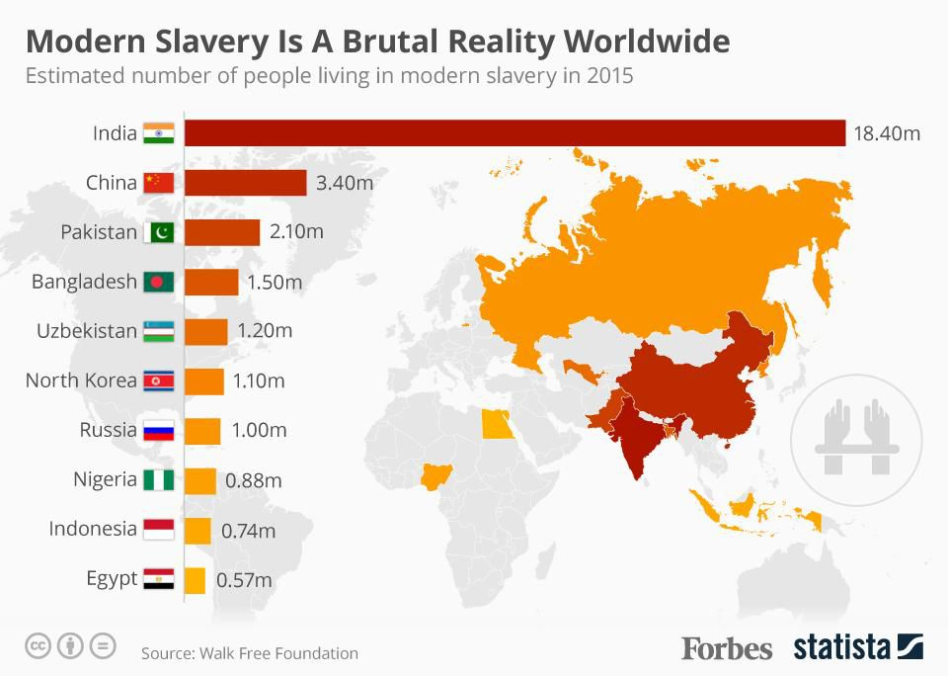

Slavery is most prevalent in countries producing consumer goods through low-cost labour. When it comes to the sheer number of people living in slavery, no country comes close to matching India. There are an estimated 18.4 million slaves in India, compared to 3.4 million in China and 2.1 million in Pakistan.

**Drivers behind the business:**

Poverty and a generally poor human rights situation are two one of the most important drivers of this type of modern slavery. Many people would do anything to feed their families, which is not wrong, but this is the reason why people are exploited. Illiterate people often sign a contract without knowing its terms. This can easily turn into a form of servitude.

**Measures:**

Numerous "non-governmental organisations", in short "NGOs", which are independent from governments, fight against poverty and campaign for human rights. The support and expansion of NGO-activities are therefore an important contribution to stopping exploitation and enslavement. Furthermore, buying fair trade products are another alternative. “Fairtrade” products are more expensive, but they are produced 100 percent through fairly paid voluntary work and good human working conditions. Poverty and slavery can also be combated by raising awareness of “Fairtrade” among consumers in developed countries. In this context it is also important not to buy products from companies that support exploitation.



**Conclusion:**

Modern slavery is a problematic issue. It is difficult to stop slavery from one day to the next, but the problem could be dealt with over several years through cooperation between government and businesses. Everybody can contribute to the fight against exploitation and slavery by changing their own purchasing behaviour.